## Group Development plan

### Project Plan



### CRC cards

 

 

 

 

### Data structure

**Basket** – linked list. The basket is going to store the elements the customer has selected to order. It will be stored as a linked list because we are going to be adding/removing elements frequently.

**Item list** – The item list is going to be storing the items the coffee shop has on sale. It will be stored in a tree set because the list will be searched through often, we want to display the items in order and we don´t want duplicated of the type items we have on sale.

**Discounts** – map. The Discount list will store all the combinations of items which are on discount. It will be stored in a map, because each combination of elements need to have an unique key, we want to easily store combinations and don´t want duplicate discounts.

### UML

Description of colours:

 CLASSES ENUMERATIONS  METHODS

PROPERTIES  FILES  CONSTRUCTOR

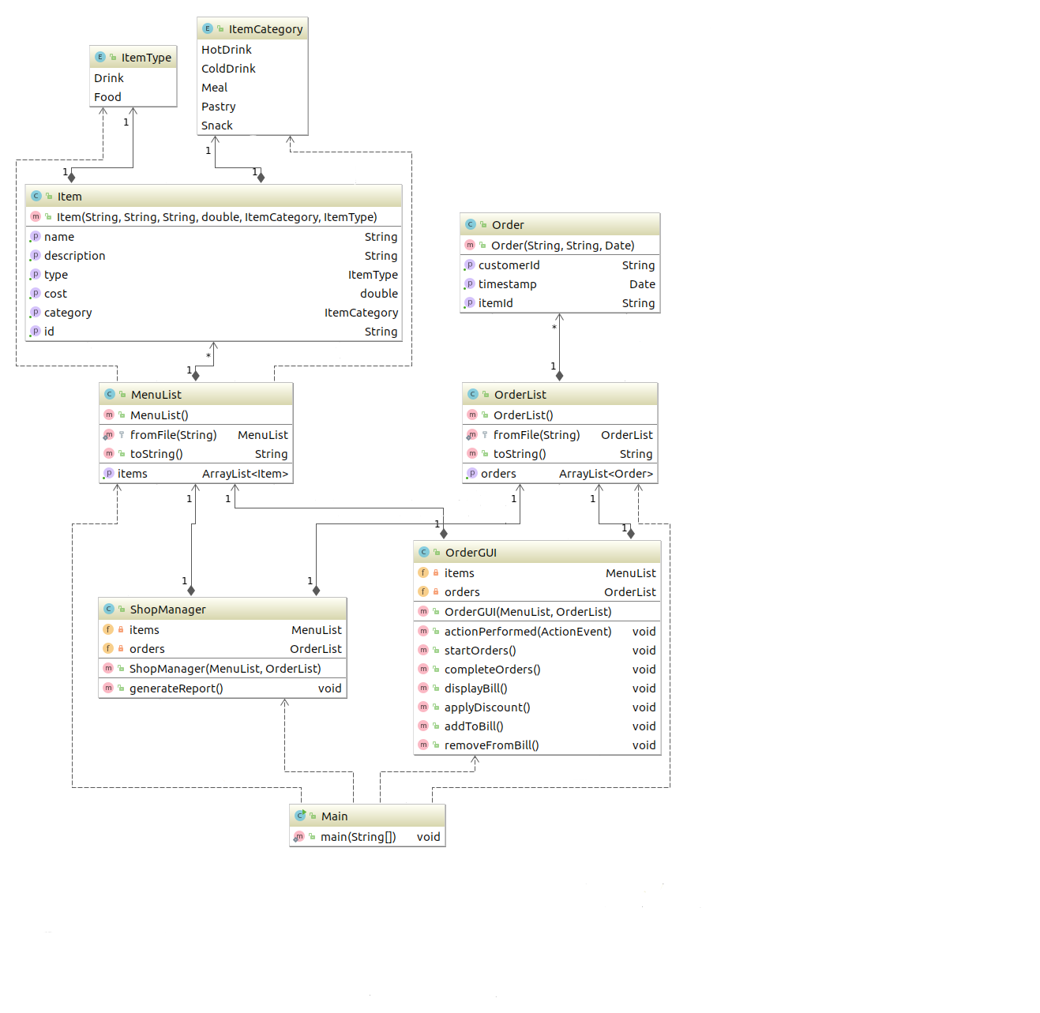

### Use Case Diagrams

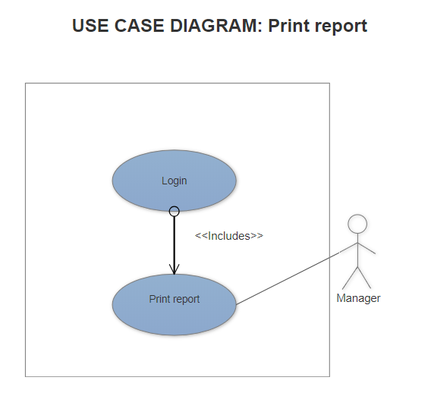 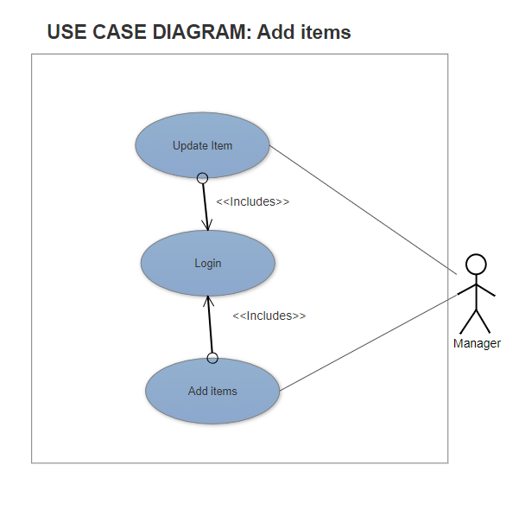

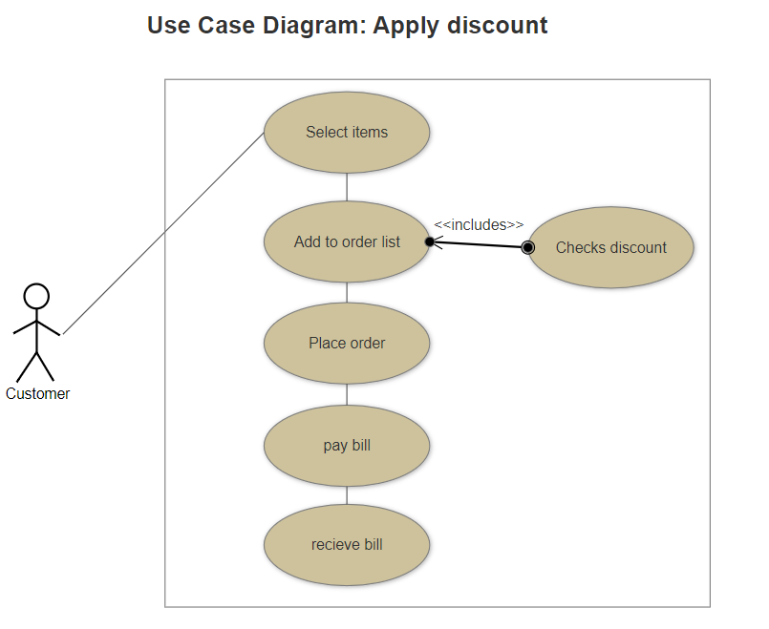

### Activity diagrams

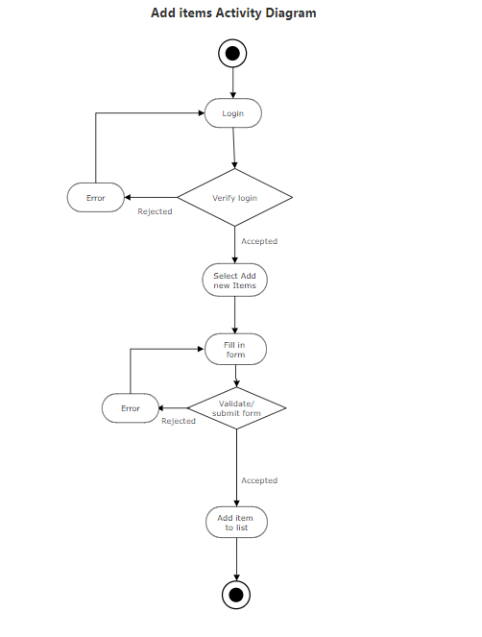 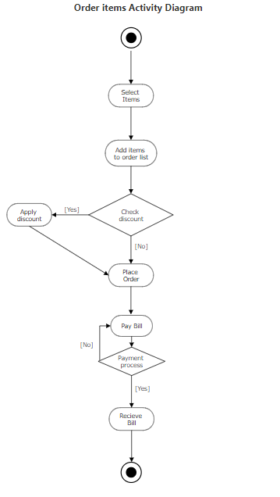

GUI

